## A New Model for BCF Project Organisation

## 比特币现金基金的新项目组织模式

Right now the community is disorganised. To make the most of our resources we need to improve the organisational model of the community so that our output is maximised and we succeed in achieving as much awareness and adoption of Bitcoin Cash as possible.We have two broad resources:

目前社区正处于散乱的处境。为了最有效地利用我们的资源，我们必须改善我们社区的组织模式来达到最大成果，也让我们尽可能达到更多对于比特币现金的意识以及应用。我们拥有两种广大的资源：

1. Funds donated by donors and sponsors.

来自捐赠者以及赞助商的资金

1. A passionate and skilled community willing to volunteer to help Bitcoin Cash succeed.

充满热忱以及持有多方技能的社区，愿意自愿帮助比特币现金取得成功

We need to find a way to combine these two resources in the most efficient way possible to achieve massive awareness and adoption. So how do we do this? Below is a basic model of how this can be achieved.

我们必须探讨如何结合这两种资源，以最有效的方式来取得广大的意识与应用。要如何做到这一点？以下是个基本的模式来说明怎样实行这项任务。

**What do we have now?**

**目前我们拥有什么？**

The current model that we have now was chucked together over the past 10 days. We reach out to the Bitcoin Cash community through some social media platforms and attempt to get them into a Slack group. To defend against trolls and bots we cannot link to the signup page publicly. This means we have to manually message the link to every person who wants to sign up. Then once they signup they are put into the lobby by default. Most discussion goes on in private channels though, which means new people joining have to be manually added to all the private channels. This takes a lot of time when you have to do this for hundreds of people. For thousands of people, this would simply be impossible. This is what I have spent a huge amount of time doing the past week and a half because I know how important it is to gather the community while we have momentum, but this is not a scalable or realistic solution for the future.

我们现有的模式是过去十天里拼凑起来的。我们通过各种社交媒体与比特币现金社区成员沟通接触，试着引导他们加入一个Slack团体。为了防范巨魔以及机器人的扰乱，我们无法公开透露登记页面的链接。这意味着我们得通过手动方式向每个有兴趣的成员留言。一旦登记，新成员只能在‘lobby’聊天室参与议论。大部分的议论都局限于私密频道，若新成员想要参与，就得通过手动方式把他们加入私密频道。为上百个人这么做实在是太费时了，为上千人数这么做简直就是不可能的任务。我在过去一个半星期里为这件事费了不少的时间，因为我了解在势头正旺时聚集社区的重要性。但对于未来，目前使用的方案即不切实际，又没有扩展的空间。

The other problem with Slack is that it is great to discussing ideas and connecting with people, but it is a terrible platform for making definitive progress on a project with a team of people potentially scattered all around the world. Valuable ideas are simply washed up the page never to be seen again. For project development and management, a communication platform with more permanence is required.

Slack的优点是它能让人进行构思研讨以及与他人接触。但是，把它作为一个协作平台，与来自世界各地的项目团体成员来促使项目进展，Slack是无法胜任于此。宝贵的意见往往在此前沟通记录消失。对于项目发展以及管理，一个较有持久性的沟通平台是不可或缺的。

**A Rough Model for Community Organisation**

**社区组织的概要模式**

In the model defined in Figure 1 below, we pool the community into one major platform that is able to meet our requirements. We do this by bringing people in from all the different social media platforms (and real-world events such as meetups and conferences).The community can the self-organise into teams and develop their own projects to be submitted to the BCF. The BCF can then fund the projects that will have the most impact, and the teams can then execute the projects to increase awareness and adoption of Bitcoin Cash.

根据以下图形1展现的模式，我们把社区成员集中于一个能符合我们需求的主要平台。我们可以通过各种社交媒体（以及实际活动，例如聚会与会议）集合有兴趣的成员。社区可以通过自我组织的方式组成不同队伍，向基金提议发展自己的项目。基金将会供资最具有影响力的项目，让这些队伍实行他们的项目来提高比特币现金的意识以及应用。

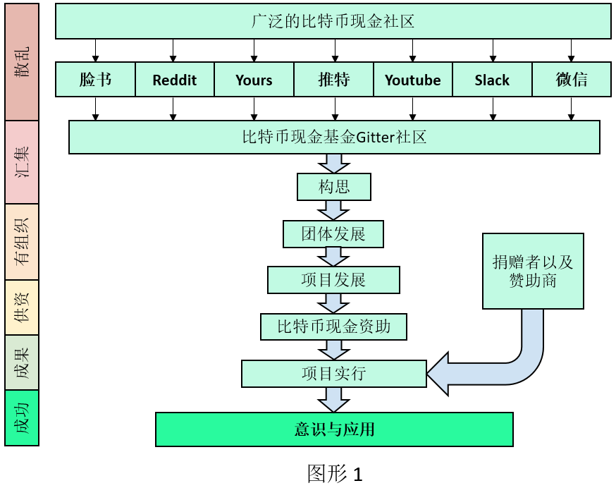

This is easier said than done though. In the next section, I will describe a detailed model of how this can be achieved.

说起来容易，做起来难。在下一段，我将描述一个详细的模式来说明如何达致此目标。

## The BCF Community Management Model

## 比特币现金基金的社区经营模式

The model shown in Figure 2 uses three platforms to communicate the bulk of the information.

图形2展现的模式利用三种平台来传达大部分的资讯。

* **Github**
* **Gitter**
* **Trello**

**Github** is to be used as a more permanent and structured platform for project development. It can be used to create and manage different file types, make project PR updates, communicate through the Issues feature. Github is already known to work well for even larger, complex projects with very large numbers of contributors, and it is completely free to us.

我们将利用Github为较有持久性以及有系统的平台来应付项目发展。它能让我们制作与管理各种文件类型、发布项目PR公告、以及通过Issues功能来沟通。就算项目再有更多的贡献者，Github已经证明了它能为更大更复杂的项目提供良好的效应。再加上，它是个完全免费的工具。

**Gitter** is to be used as the fast and direct communication channel where things can be discussed with large numbers of people at any time. Like Slack, it is a great place to pull in new people for general discussion of ideas. You can sign up for Gitter with your Github account so no extra account is necessary and everything is linked. Gitter is also publicly visible unlike Slack, which means that anyone will be able to see all the progress we are making and can jump in at any time effortlessly. New rooms can be created for specific projects and everyone will be able to join in if they want to.

Gitter将会是我们使用的通讯通道，即快又直接，在任何时候能让多数成员一起进行讨论。如同Slack，它也非常适合让新人加入参与一般性的构思讨论。您可以利用Github账户就能开始使用Gitter，不需要额外的账户，两个平台一起链接。与Slack不同的是，任何人可以观察我们在Gitter上的进展，想在任何时候参与简直是轻而易举。我们可以为专门项目提供新的聊天室，随时都欢迎任何人加入。

**Trello** will be used as a simple place for the BCF to track the progress of projects. The BCF Trello page will be public so that anyone can see which projects are actively being worked on and will have access to connect with them on Gitter and Github to join in.

Trello是个简单的平台让基金跟踪各个项目的进展。基金的Trello页面将会公诸一世，让任何人可以观看正在积极实行的项目，若想参与项目他们可以通过Gitter以及Github与有关成员联系。

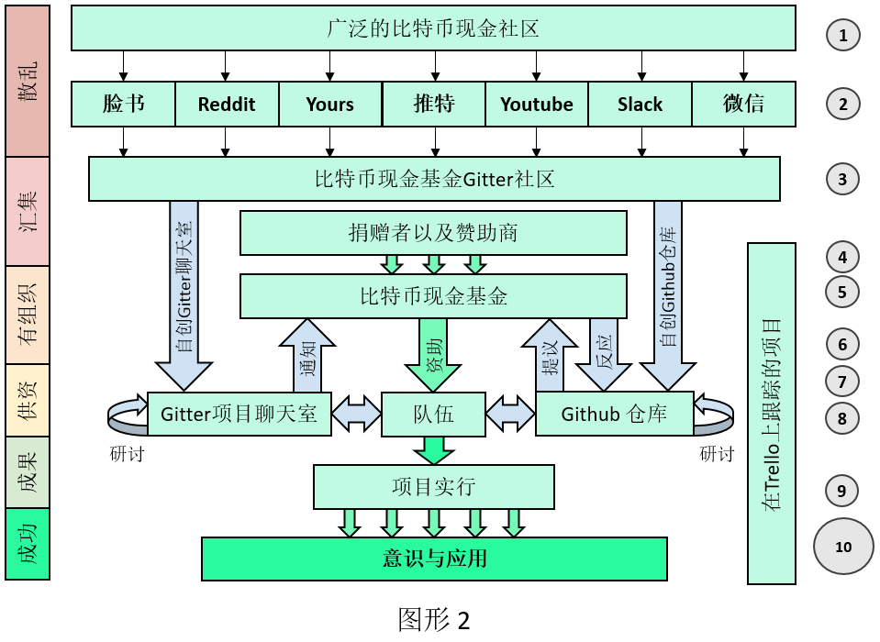

The model shown in Figure 2 is detailed below.

以下详述图片2展示的模式。

We have to move from point 1 (a disorganised community) to point 10 (awareness and adoption of Bitcoin Cash).

我们必须从第一点（散乱的社区）走到第十点（比特币现金的意识以及应用）。

1. We start with the broad, disorganised community spread all across the world, using all different communications channels and platforms.

我们利用不同通讯通道，与来自世界各地的广泛、散乱社区成员们沟通接触。

1. We start finding the current and potential Bitcoin Cash community via multiple social media channels and direct them to the BCF Gitter community.

我们通过各种社交媒体开始寻找比特币现金社区的现任与可能成员，引导他们加入基金的Gitter社区。

1. The community pools into the general BCF Gitter community rooms and are free to participate in the rooms dedicated to specific fields (e.g. Video Production or Graphic Design rooms etc.). All rooms will be publicly visible (unlike slack).

社区集合于一般性的各种基金Gitter社区聊天室，成员可以随意参与专门特定方面的聊天室（例如视频制作、平面设计聊天室等）。

1. The community develops ideas for projects to work on and self-organise into teams of people with the relevant expertise and will to complete the project.

社区研讨项目构思，以自我组织的方式把持有相关才能与坚定意志的成员组成团队来完成项目。

1. One or two leaders are chosen voluntarily to lead a project and team.

一到两名组长自愿挑选，带领项目以及团队。

1. The leader(s) creates a separate Gitter room for the project and invites all of the team to it. The leader(s) also creates a new Github repo and invites all the team to that. The leader then notifies the BCF of the project, the room, and the repo so that they can track the project on Trello publicly, and put a link and information about the project. This is so that anyone who wants to join in or follow the project can.

组长为项目自创单独Gitter聊天室以及新的Github仓库，并邀请团队成员加入。组长必须通知基金相关的项目、聊天室、以及仓库，以便基金在Trello上跟踪项目进展并放置项目资讯以及链接，方便任何人参与或跟踪此项目。

1. The team discusses the project in their Gitter room and in their Github repo until it is well-formed enough to [**FILL OUT**](https://github.com/The-Bitcoin-Cash-Fund/Docs/blob/master/BCF-Funding-Proposal-Request-Template.md) and submit a solid FPR ([Funding Proposal Request](https://github.com/The-Bitcoin-Cash-Fund/Docs/blob/master/BCF-Funding-Proposal-Request-Template.md)) to the BCF. An FPR is created as the first commit to the project Repo on Github and will be a reference for anyone who wants to join the project. This FPR is then submitted to the BCF for review.

团队首先在自己的Gitter聊天室以及Github仓库上研讨项目计划。一旦有了较完善的计划，团队可以利用[这份文件](https://github.com/The-Bitcoin-Cash-Fund/Docs/blob/master/BCF-Funding-Proposal-Request-Template.md)填上内容，然后向基金提交资金提议计划。资金提议计划是Github项目仓库里的第一个commit，任何想参与项目的人可以参考此份计划。基金将会把这份计划进行审查。

1. The BCF then either accepts the proposal or returns it back to the team with feedback on what is wrong with it. If the proposal is accepted, the funding is provided as necessary, and the project is moved into ‘Funded’ status on Trello.

基金要么就接受提议，要么就把提议向团队退还，并提供反馈意见。如果基金接受了提议，项目必然受到供资，在Trello上也会显示‘Funded’。

1. The team then execute their project. Progress will be tracked by the BCF to make sure the teams have the resources they need and that they are progressing well.

团队可以将把项目实行，基金将会跟踪项目的进展来确保各个团队都有需要的资源来顺利进展。

1. If the project is successful it will be executed and will increase adoption and awareness of Bitcoin Cash.

如果项目取得成功，这将会提升比特币现金的意识以及应用。

## What do we achieve with this new model?

## 新的模式会为我们带来什么好处？

* The community is scalable to any size.

无限社区扩展空间

* The community is transparent and publicly visible.

社区活动即透明，又能让任何人观察社区的进展

* The projects BCF is funding can be easily found and tracked.

有便于查寻跟踪比特币现金基金所资助的项目

* Low effort for new community members to join.

方便新成员加入社区

* Fast discussion of ideas and team development is possible.

可以进行迅速构思研讨以及团队发展

* Slow, permanent and methodical discussion of the project by stakeholders possible.

相关方可以进行缓慢，持久以及有系统的项目研讨

* Minimal work required to implement and maintain.

要实行以及保持是件毫无费力的事

* Can be implemented immediately

可以马上实行

* Zero cost for everyone.

不需缴付任何费用

First join Github [HERE](https://github.com/) if you haven’t already.

首先，如果您还没加入Github，请在[这里](https://github.com/)加入。

Then join Gitter at our BCF community [HERE](https://gitter.im/Bitcoin-Cash-Fund/Lobby) using your Github account.

然后通过您的Github账户，请在[这里](https://gitter.im/Bitcoin-Cash-Fund/Lobby)加入Gitter与我们的比特币现金基金社区接触。

Our Trello page can be viewed [HERE](https://trello.com/b/vII31atU/projects) at any time to track the BCF projects.

您可以随时在[这里](https://trello.com/b/vII31atU/projects)观看我们的Trello网页来跟踪比特币现金基金的项目。